

|  |
| --- |
| Apparel & Footwear |
| **Supplier Stock for Outsourced Production** |
| Argentis Consulting |



**www.argentisconsulting.com**

**Supplier Stock for Outsourced Production**

In outsourced manufacturing scenarios, some customers create purchase order for the finished goods but they own some materials or semi-finished goods like hangers, labels, etc. In this case when the products are received at the warehouse, these materials need to be removed from stock. The issue is that the stock is at the vendor warehouse and there is a need for the customer to check the stock at the warehouse.

**Setup**

Go to Apparel and Footwear 🡪 Setup 🡪 General setting 🡪 Tab: Production.

Select field “*Release Raw Materials from Vendor warehouse”*

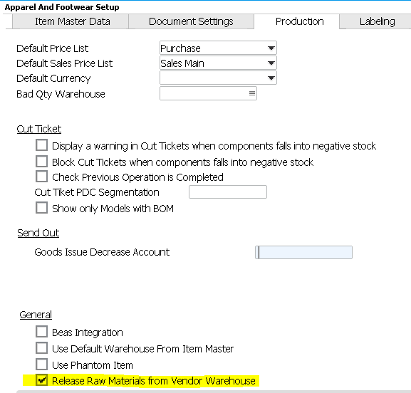

**Proposed process**

*1-* *Create Style / Cost Sheet*

Create the style and add the cost sheet. In the Cost Sheet, enter the material, as an example Hangers. Select ***“Vendor Raw Material: Yes”*** will be added**.** This will allow to select the materials from the cost sheet to be released after the goods receipt PO is created in SAP. Other costing items will not be released or take part of this process.

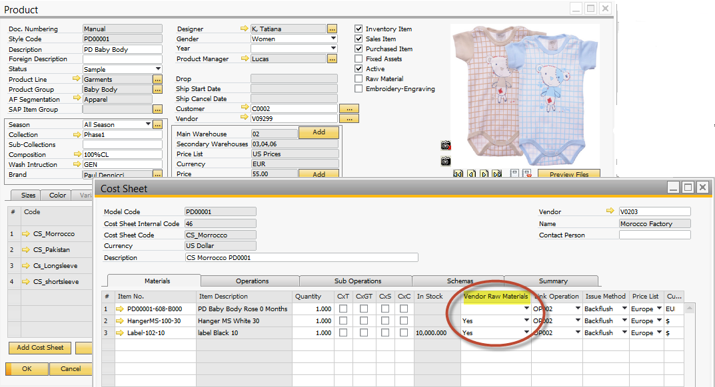

If MRP to create purchase orders for hangers is needed the user will have to create the BOMs. Specify the vendor warehouse on the hangers.

*2- Buy raw materials / receive at vendor whse or internal whse*

Complete the default whs of the Vendor in “Default Warehouse”

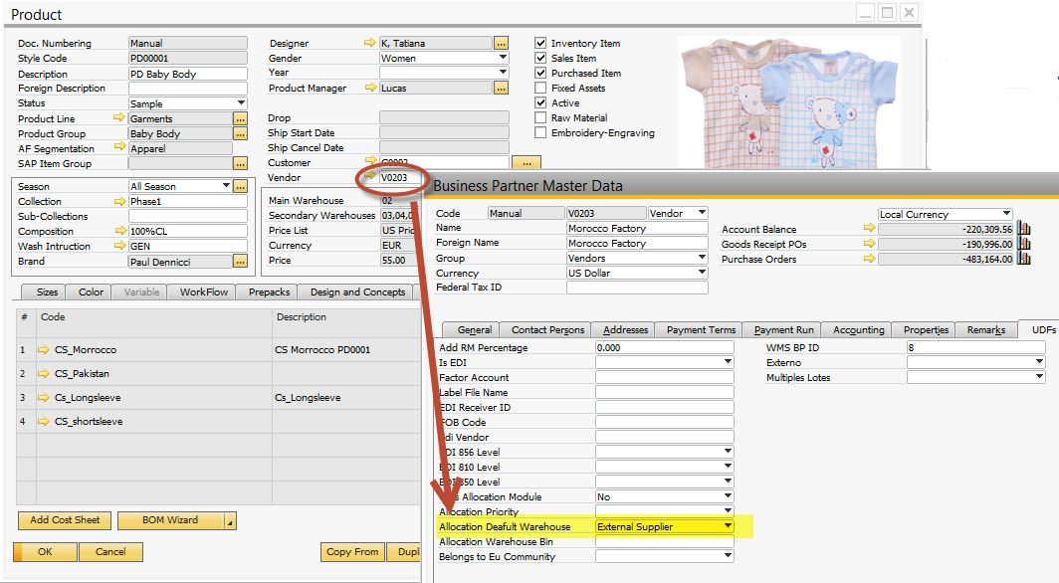

Receive to the vendor warehouse.

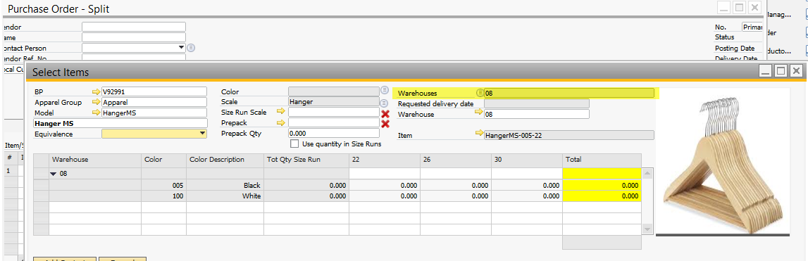

Or Receive in internal whs and then Transfer it to the Vendor whs

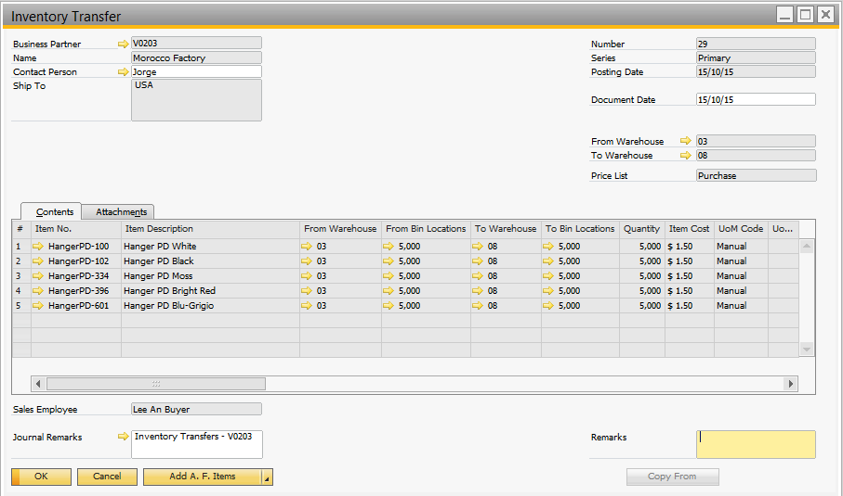

3- Create PO for finished goods

The PO creation and Good receipt follows the standard process. In this case 50 items in total. As the cost sheet specify 1 hanger per item, the wizard will release 50 hangers in total from the vendor warehouse.

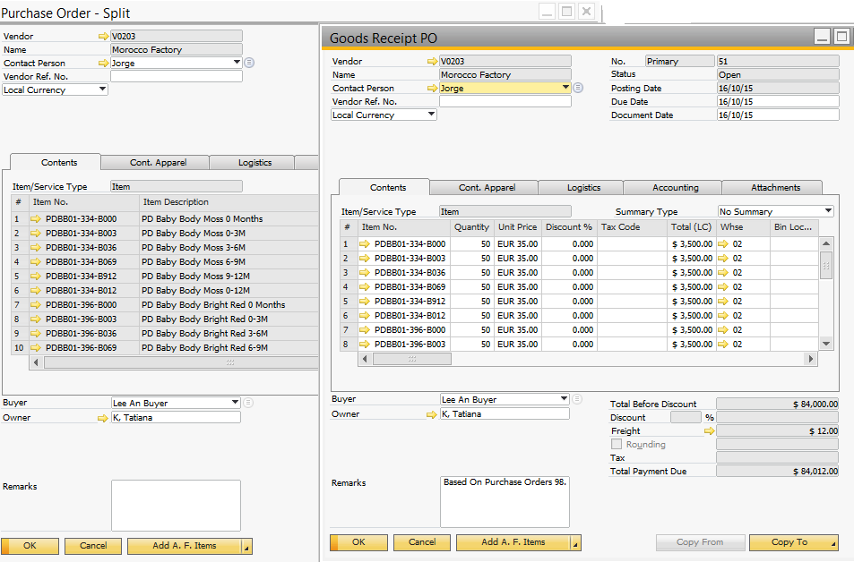

4- Goods Issue

This process is triggered when receiving goods. After creating the goods receipt PO, select from the Menu the option “Vendor Inventory / Cost Wizard”.

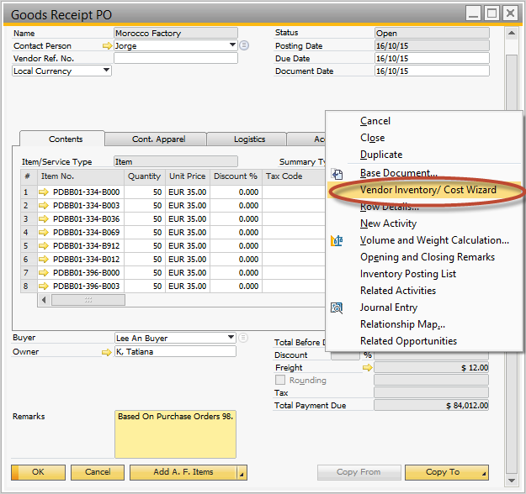

* Step 1. Select all items to be released from the vendor warehouse. And Select option “Generate document”

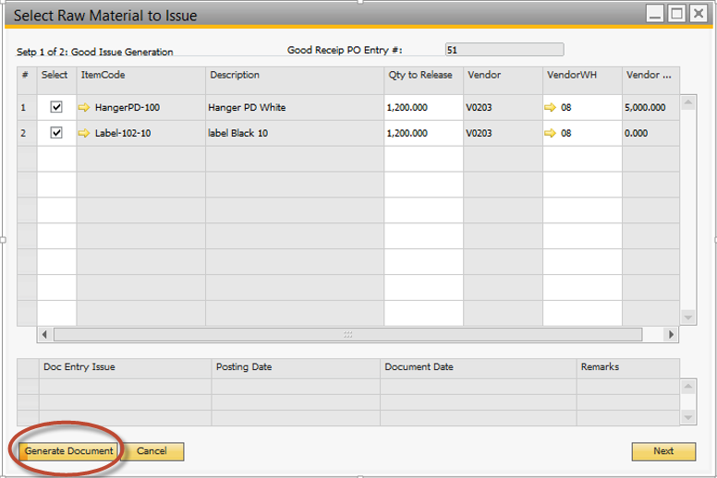

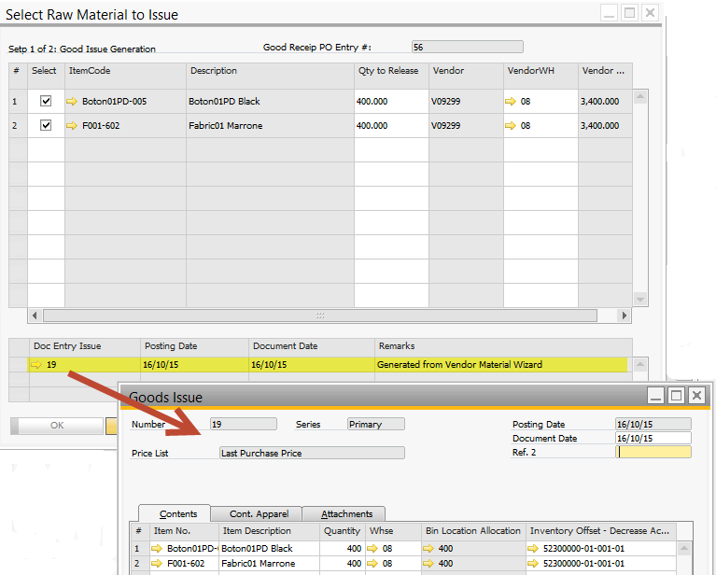

A Good Issue is created against the Raw Materials decreasing the stock from the Whs of the Vendor.

* Step 2. Run a revaluation process for the styles received.

Select “Next” to continue with the Wizard to the step of Cost Revaluation.

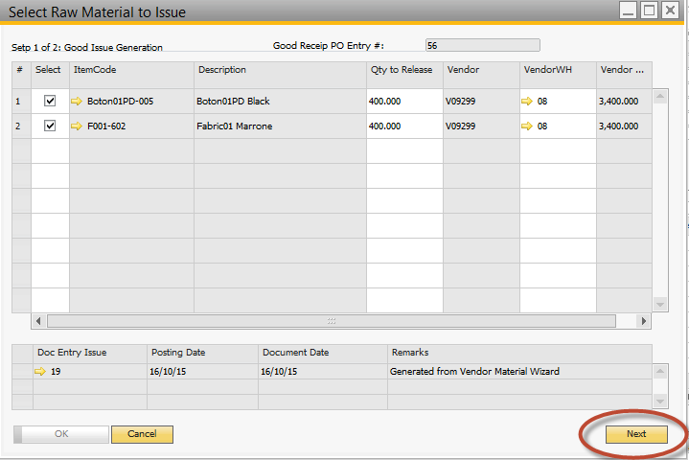

An Inventory revaluation for the finished products will be created, after select option “Generate document”

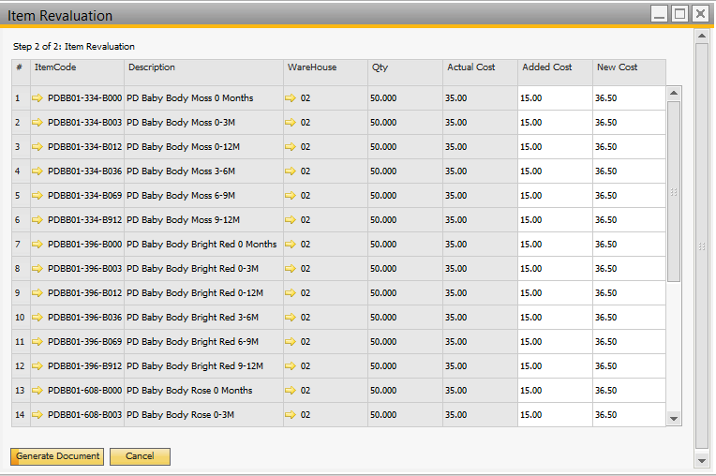



**www.argentisconsulting.com**

|  |  |
| --- | --- |
| **USA**  9744 NW 45th Lane  Doral, FL 33178  info@argentisconsulting.com | **ARGENTINA**  Ávila y Zarate 2048  Cerro de la Rosas, Córdoba,  CP 5009  Córdoba - Argentina  info@argentisconsulting.com |
| **CARIBEAN**  City View Plaza – Suite 301  48 Road 165  Guaynabo, PR. 00968  Puerto Rico  caribe@argentisconsulting.com | **SPAIN**  C/ Juan Bravo N° 3 A 28006  Phone: (+34) 91 123 7263  Madrid - Spain  info@argentisconsulting.com |

**INFORMACIÓN DE CONTACTO**

**Argentis Consulting** is dedicated to the development, distribution   
and support of recognized certified solutions for SAP Business One.   
As an SAP Software Service Provider Partner with Gold Status.